Online

Shop.4

DVDS

PROJECT

GROUP MEMBERS

|  |  |
| --- | --- |
| **NAME** | **ENROLLMENT** |
|  |  |
| Arbab Ali Khan | 1312189 |
| Ibadullah | 1310986 |
| Asadullah | 1288912 |
| Sanaullah | 1310985 |

CURRICULUM

**“OV-ACCP Prime-6740-ACE**”

**BATCH**

**“2103C2”**

**FACULTY**

“Miss.Muniba Khan”

**CO-ORDINATOR**

“Miss.Ariba”

Home Controller:

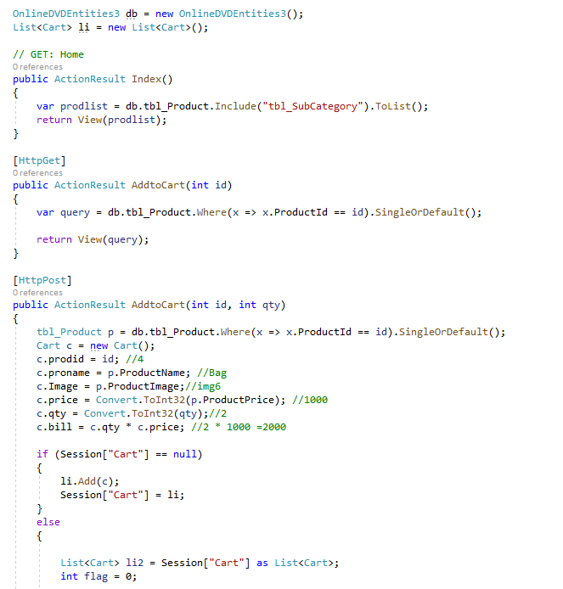

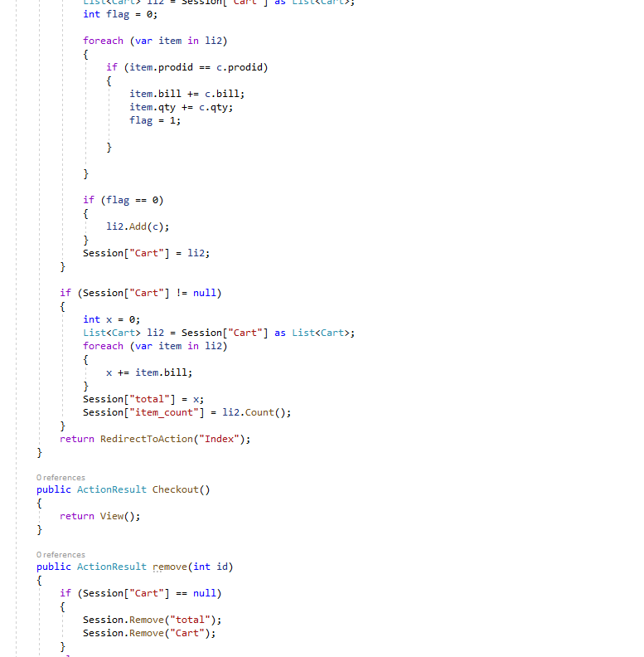

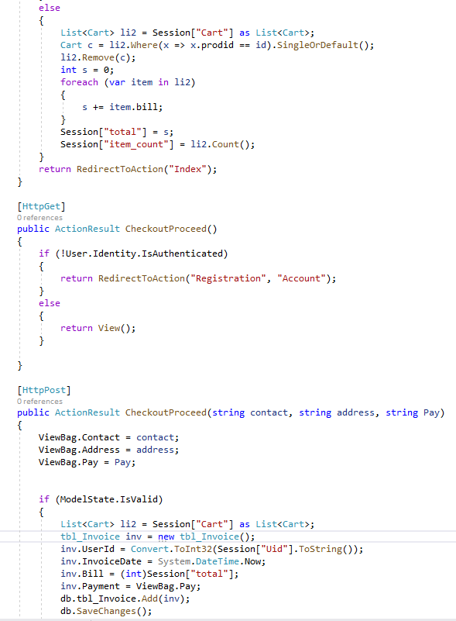

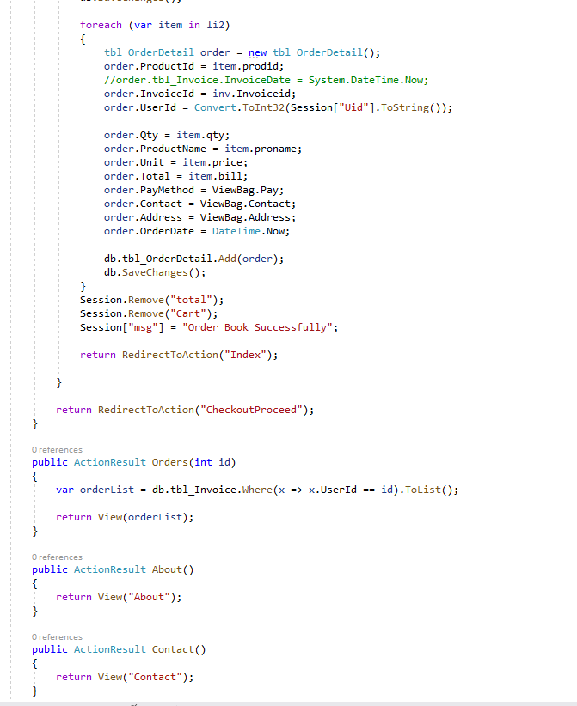

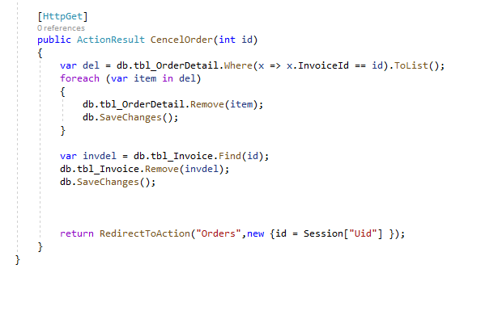

Login And LogOut:

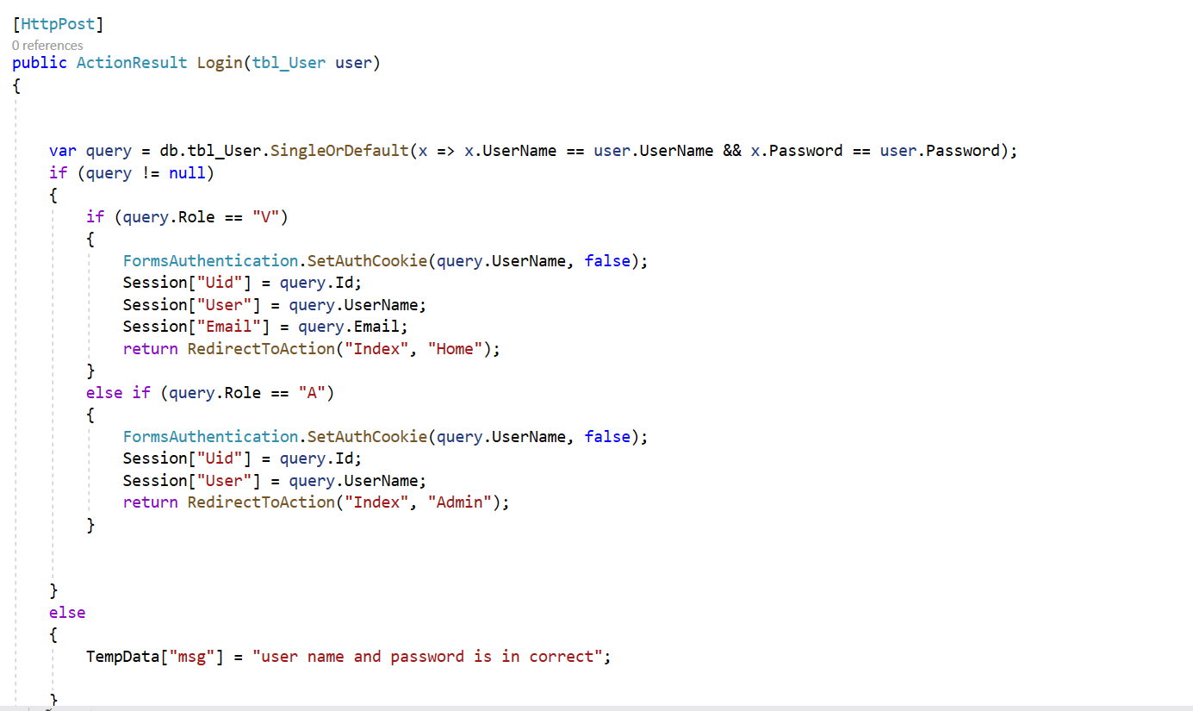

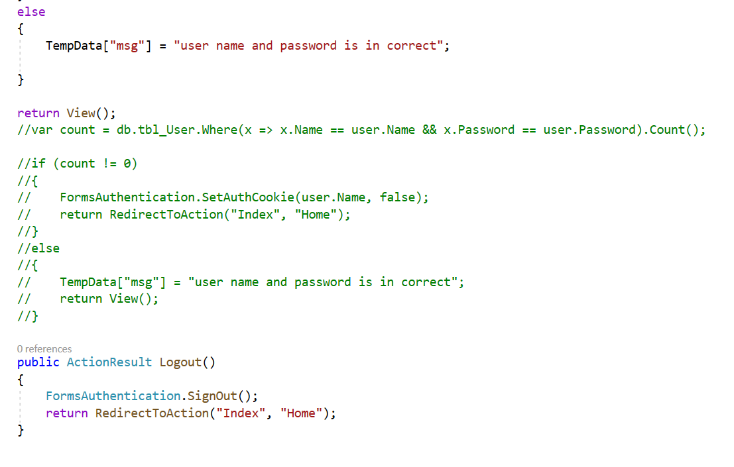

Registration:

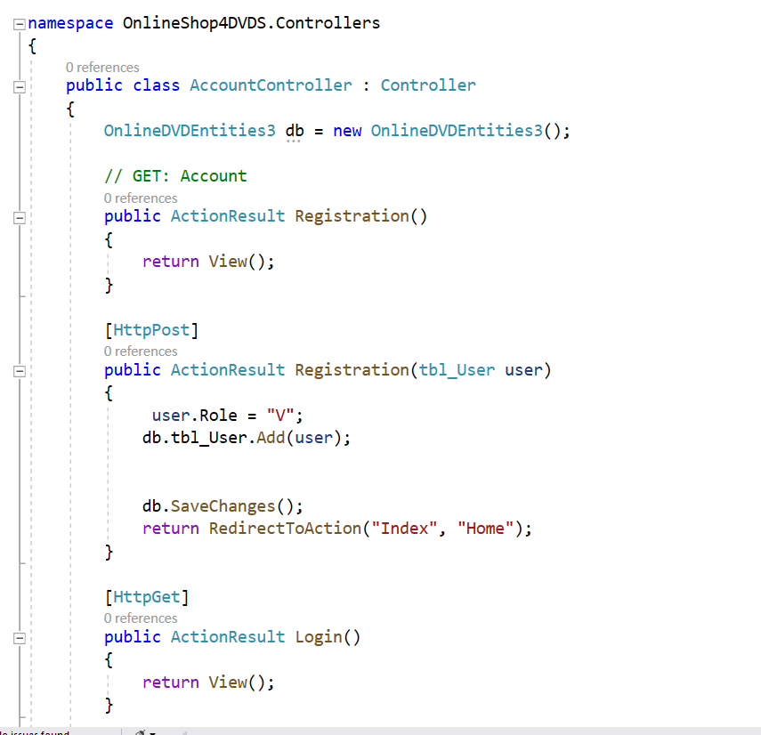

Edit:

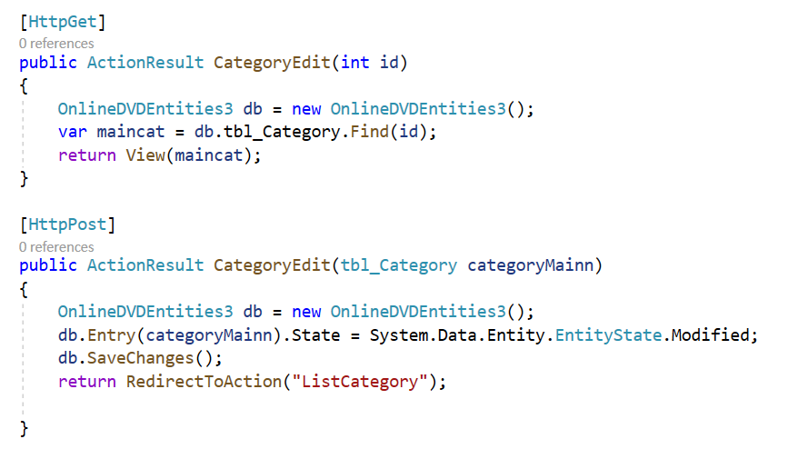

Delete:

